09.07
Outstation & MRO
Process Design & AMOS Configuration Document
Purpose
This Process Design document is provided to Key-Users to record their key decisions regarding the AMOS Process design and the required AMOS configuration.
It is updated throughout the Project Definition Phase and used as the baseline for the Final Acceptance prior to Go-Live
Revision
Author, Name | Date | Notes
Daniele Musella | 01.06.2024 | First version

Table of Contents

1. Process Overview & Objectives 3
2. Regulatory References 3
3. Definitions & Glossary 3
4. Process Tasks 4
5. Process Dependencies 6
6. Process Flow 7
7. Process Design Questions 8
8. Data Source Mapping 10
9. Other Software Used 10
10. AMOS Configuration 10
a. Process specific configuration programmes 10
b. Basic Data 10
c. Parameters 11
d. Workflows 11
e. Scheduled Tasks 12
f. API’s & Interfaces 12
11. UAT Guidance 12
12. Annex – Additional Info 13

Process Overview & Objectives
Process General Description
This Business Process explains, how to move material between stations in AMOS to respond to the different use cases that a customer can have during operations.

Main Process Objective (Outputs & Outcomes)
The main objective of Outstations & MRO process is to give the users the possibility to move material effectively and efficiently between stations with reference to the following use cases:
- To move serviceable material between stations to respond to part requests in maintenance events assigned to a workpackage that is performed outstations (or anyhow, in a station different from where the material to transfer is located)
- To move serviceable material between stations to respond to part requests in maintenance events NOT assigned to any workpackage, that is performed outstations (or anyhow, in a station different from where the material to transfer is located)
- To move serviceable material between stations to replenish stock where the stock level is followed through SPA (Station Parts Alert, APN 313)
- To move serviceable material from main base to outstations as soon as they have been received in the main base from external vendors ("Crossdocking" use case)
- To move unserviceable material between stations from Repair Administration (APN 1431), typically when repair administration is centralized in the main base and the US parts removed outstations should be firstly routed to main base before sending them to internal/external repair station.
- To move serviceable/unserviceable material between stations without linking to a specific use case in AMOS (“stand alone” Transfer Order)

Regulatory References
There is no worldwide authority regulation applicable to this process.

Definitions & Glossary
Key-Words | Explanation
Outgoing  Shipment | Shipment between stations created in relation to an outgoing order (T-order, R/X/YU/PU/LU/RU/C/V/D-order). It typically includes a packing of boxes, a pro-forma invoice and (optional) DGR declaration.
Proforma Invoice | It is a transportation document whose main purpose is to provide a complete overview of the contents of the shipment, as well as the terms agreed upon between the sender and the recipient (seller/buyer), as this affects the customs value of the goods and enables the correct calculation of duties and taxes.
AWB Tracking | Tracks shipments via AWB Tracking APN (URL information required)
ADR | Dangerous Goods Shippers Declaration for Road Transport
IMDG | Dangerous Goods Shippers Declaration for Maritime Transport
IATA/DGR | IATA Dangerous Goods Shippers Declaration for Air Transport
ADN | Dangerous Goods Shippers Declaration for Inland Waterway Transport
Crossdocking | Receiving a Shipment (typically in the main base) from External Address and send it further to another Station

Process Tasks
The main business processes and related AMOS APNs are the following
To move serviceable material between stations for WP planned at outstations
This use case occurs when a maintenance event (WO, TC, SRT, SB, Replacement event, Generic Event and so on) is assigned to a WP planned outstation or, anyhow, in a station different from where the material is located. Typical example is material sent from main base to an outstation where the WP is planned/executed.
In this business process, when the material is available in another station and AMOS allocates this material to that maintenance event, we always have a part request in PCF (Parts Consumption Forecast, APN 204) whose availability status is “yellow”, namely “Transfer Needed/In Progress”.
Here the user can benefit from the so called “Automatic Transfer” feature, to be setup in the context of Material Planning process (see process 09.01 Material Planning). Thanks to this feature, in AMOS we have the possibility to automatically create T-order for all the parts that have to be moved between stations for a planned WP, in an effective and efficient way, in one of the two following modes:
- Semi-automatic mode: from PCF the user can filter, in “Event view” tab, the WP and all the part requests whose availability status is “yellow”, then multi-select all of them and to use the feature “Automatic Transfer” (available also in Part view).This will generate a T-order (also in status already “Issued”), with all the selected parts and other info like station from/to, aircraft, target date and so on already pre-filled
- Fully automatic mode. In this case, thanks to the scheduler task AutomaticMaterialTransferTask, AMOS evaluates all the part requests and issues Transfer orders if needed.

To move serviceable material between stations for maintenance event NOT assigned to WP
This use case occurs when a maintenance event (typically a WO, but also other maintenance events) that is performed in a station different from where the material is located requires the material to be moved is NOT in the station of the maintenance event is performed.

In this business process, given that there is no WP (which tells AMOS where and when the maintenance events inside it should be performed), when the material is available in another station and AMOS allocates this material to that maintenance event, we always have a part request in PCF (Parts Consumption Forecast, APN 204) whose availability status is “green”, namely “Available”.
Also in this case the user can perform a semi-automatic transfer from PCF but, differently from the use case when all part requests are assigned to a WP, in this case all part requests have availability status “green” (= available), and the user has to manually check/distinguish what are those parts request that really need transfer from other part request whose material is already in the desired station.
In this business process the Transfer order can be triggered:
- from Event view (create order>T-order). In this case the user can also multi-select part requests, but he does not know where the relevant allocated material are.
- from Part View (button “Transfer the Material”). In this case the user can see where the material to be transfer is located, but he can move only one part number at once.

To move serviceable material between stations in the SPA process
In this use case the serviceable material is moved between stations not in relation to a specific maintenance event, but with the purpose of stock replenishment where the stock level is followed though SPA (Stations Part Alert) process.

There are two modes of triggering creation of a T-order in SPA process:
- Semi-automatic mode. User manually multi selects in SPA (APN 313) the parts in status "Below or Equal Reorder Level" and the system automatically creates a T-order(s), according to parameters 1581 and 1626
- Fully automatic mode. In this case, thanks to the scheduler task AutomaticStationSupplyService, AMOS checks all station stores having the Automated Station Supply flag in APN 2409 (“scheduled”). If such a store has an active list defined in Station Parts Alert, the list gets checked for parts requiring a re-supply and AMOS automatically creates T-order(s) (parameters 1581 and 1626 are taken onto account as well).
See also process 09.01 Material Planning.

To move serviceable material between stations in the “Crossdocking” process
The Cross-Docking process refer to forwarding of parts delivered from external to be transferred to other stations of your network.

The process of unloading materials from an Incoming Shipment and loading these materials directly into
Outgoing Shipment, with little or no storage in between is performed in Shipment, APN: 2392.

To run this process in AMOS the incoming order needs to be arrived and received. The cross-docking feature.
will create a Transfer order and auto-confirm the Pickslip for material that is forwarded to its final destination.
Within the shipment application also the respective paperwork can be printed.

In the original external order, the final destination should be indicated in the “Ship To”, while the intermediate destination where the part is received (typically the Main Base) and then forwarded to the final destination has to be indicated in the field “Ship Via”.
Example. If a part is needed in BSL, but I want to receive the part in ZRH (main base) and then forward the received part to BSL, in the external order towards the vendor I need to indicate BSL as “Ship To”, while ZRH as “Ship Via”.
Pay attention: the supplier must be informed that he has to send the part to the address specified in “Ship Via”, and not “Ship To”.

To move unserviceable material between stations from Repair Administration
This use case typically occurs when repair administration is centralized in the main base and the US parts removed outstations should be firstly routed to main base before sending them to internal/external repair station.

The starting point here is Repair Administration (APN 1431), where US parts removed in a given station (with their temporary R-order) can be multi-selected and trigger an automatic T-order, where the only information needed to create the T-order are the destination station/store and the “Issued by”.

The T-order automatically created with contain all the info of PN, SN, qty, label and so on. In this process, as soon as the T-order has been created and as long as the T-order will be received, the same part will have two open orders on it: the temporary R-order and the T-order. See below a screenshot taken from Order Tracking (APN 1328)

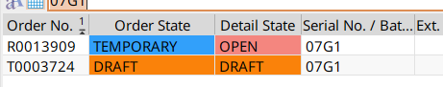

To move serviceable/unserviceable material between stations with stand-alone T-order
In this use case a T-order is created directly from APN 2015, and all the fields of the order header (station/store From, station/store To) and order detail (part numbers, serial number, quantity, project, aircraft and so on) should be manually filled.

In case you need to move several parts, this process could be time consuming, cumbersome, and prone to human error in the manual filling process of one of the fields that should manually be filled. That’s why we recommend using the T-order process as much as possible in relation to one of other use cases mentioned above.

Transfer Order Process
The T-order process flow is shown to chapter 6. What it is important to highlight here is that:
- Even though the T-order can be crated from scratch in APN 2015, it is recommended to trigger its creation from one of the other APN (APN 204, APN 313, APN 1431, APN 2392, Scheduler Tasks) related to corresponding use cases explained above
- Depending on the use cases, T-order can be created in status DRAFT or already OPEN (Issued).
- The T-order always need a PSL to be issued out of it and then booked. However, it is possible to assign the parameter [IPA] (Issue Pickslip Automatically) to order type T (APN 1014>Orders>Extras) so that a pickslip for the whole T-order will automatically be issued upon issuing of T-order.
- If the parameter [ABP] (APN 1014>Orders>Extras) is active on the T-order, the as soon as all items of pickslip will be booked, AMOS will automatically book the T-order as well.
- Best Practice wants that an “internal” shipment is created out of the T-order. The Internal Shipment works as an Outgoing shipment for the "sender", while as an "Incoming" Shipment for the receiver.
- As any other outgoing shipment (see process 10.01 Logistics), for the shipment issued out of the T-order it is possible to create transportation documents like proforma invoice and DGR declaration.
- Once the T-order is booked, it is possible to receive it at destination station in the Goods Receiving (APN 2121). In case only some details of the T-orders are booked, it is still possible to receive the booked details in Goods Receiving.
Order Tracking
All Orders are searchable in Order Tracking (APN 1328). This report can be filtered by order state, order responsible, and order vendor. As in all table-views in AMOS, this table can be exported to Excel. The financial value of open Orders can be reviewed in the Financial Reports (APN 1355) “Value on Open Orders” report. An automatic “Order Reminder” service can be activated via the Scheduler Task “OrderReminderService”.

Shipment Tracking
It is possible to track and get an overview of all shipments in the AMOS program “Shipment Tracking” (APN 1208)

Process Dependencies
INPUT | CONCURRENT | OUTPUT
- 09.01 Material Planning  - 09.03 Ordering  - 09.04 Repair & Exchanges  - 10.01 Logistics |  | - 10.01 Logistics  - 10.02 Goods Receiving & Inspection

Process Flow
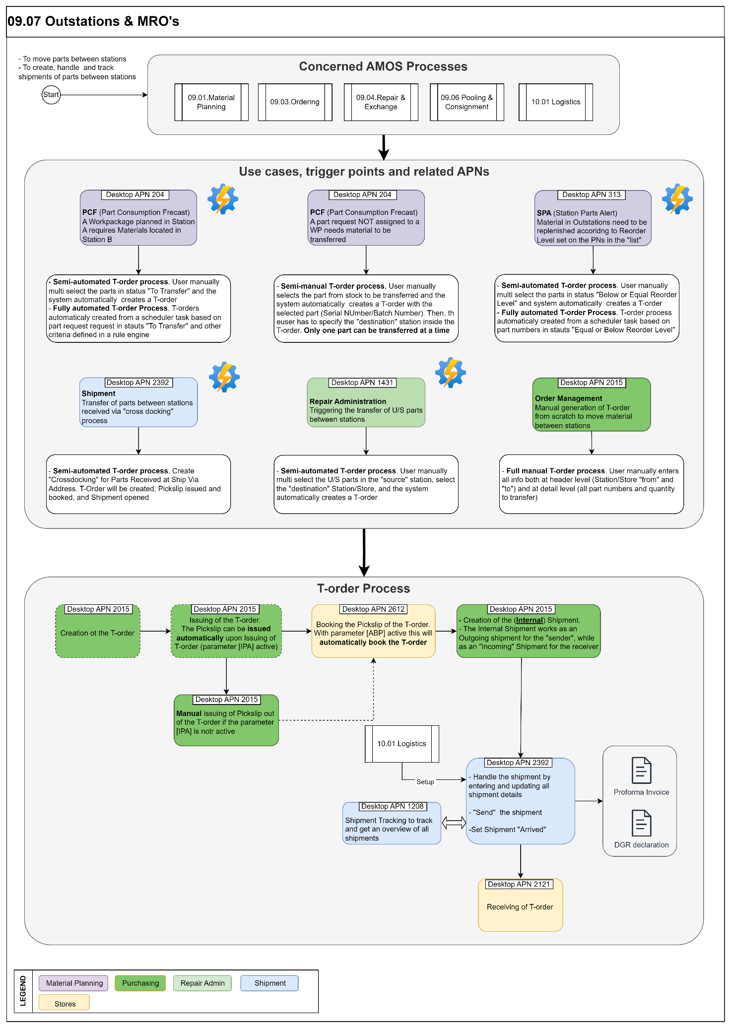

Process Design Questions
# | Question | Answer
1 | Are Outstations supplied on a fixed schedule?
2 | Who is responsible to transfer parts between stations?
3 | Is Production allowed to request parts from other stations?
4 | Is there a central receiving station?
5 | If parts are transferred, do they need to be inspected again by the receiving station?
6 | If parts are transferred between stores at the same station, is it done by one person or is there a handover of responsibilities?
7 | Are unserviceable components transferred between stations?
8 | Are mobile devices used in stores?
9 | Are shipments for internal transfers between stations recorded and tracked?
10 | Are you using APN 2392 to create and handle shipment?
11 | Do you perform Cross-Docking?
12 | Do you use forwarders?
13 | Do you have consolidated shipments?
14 | Will Customs Declarations be performed in AMOS?
15 | Who is responsible to issue and process Outgoing Shipments (typically stores or dedicated shipment departments)?
16 | What kind of AWB tracking is currently in place? How will this be reflected in AMOS?
17 | Are Shipments shipped FROM all Stations/Stores or is there a centralized shipping department?
18 | Are Shipments shipped TO all Stations/Stores or is there a centralized shipping department?
19 | Will Proforma Invoices be generated from AMOS?
20 | Will Dangerous Goods Shippers Declarations be generated from AMOS? (IATA, ADR, RID, ADN, IDMG?)
21 | Should FedEx be interfaced?
22 | Are package weight/size recorded?
23 | Is there a regular transport between stations?

Data Source Mapping

Data Sources | Description | Volume / Manual / Automatic / Static / Dynamic
-/- | -/- | -/-

Other Software Used

Other Software | Used by: | Description
-/- | -/- | -/-

AMOS Configuration

Process specific configuration programmes
AMOS APN | Notes
-/- | -/-

Basic Data
Basic Data Table | Notes
Class Division | Dangerous Goods Classes - prefilled
Dangerous Goods Transport Regulations | Standard Transport Regulation Forms - prefilled
Packing Instructions | Packing Instruction Codes - to be filled by customer - assigned to PNR
UN Numbers | UN Dangerous Goods Codes - to be filled by customer - assigned to PNR
Commodity Codes | Customs Declaration Codes - to be filled by customer - assigned to PNR
Method of Transportation | Methods of Transportation - prefilled
Type of Service | Type of Service of Forwarded - to be filled by customer
Country | This table contains the countries. These countries are used in Address Administrations.
Commodity Codes | The commodity code is a code assigned to a product or a group of products for the purposes of identifying it in international commerce or commerce in general. The code is an eight digit number specifically for exports coming from the EU, though it also can include goods moving within the EU.
Customs Classification | Can be used as Export Control Classification Number (ECCN).
Customs Status | Special status printed on the order. This is useful when shipping material to other countries, some customs need to have this.
Customs End Use | Customs End Use is the "End-Use Authorisation" text that is displayed on the Proforma Invoice. It`s used in the Shipment modules.  End Use is a Customs Regime used throughout the E.U.  It is not just for Aircraft but where goods for certain uses are exempt from duties & taxes.
Customs State | The user can set different states for defining their customs clearance process. The prio is to set the order of the different step

Parameters
Parameter Code | Parameter Name | Notes
1338 | CUSTOMSNO REQUIRED FOR RECEIVING
1354 | CUSTOMS UTILIZATION TERM
1379 | ENALBE CUSTOMS VALUE FOR V,D
1194 | Incl. alternates in Station Parts Alert
1581 | Supplier Quantity Check
1626 | Use pickslips or transfer orders in Station Parts Alert
1524 | AWB NUMBER SEQUENCE
[IPA] | Issue Pickslip Automatically for T-order (APN 1014)
[ABP] | Book order on confirmed pickslip for T-order (APN 1014)
[ULV] | Use legacy view by default for T-order (APN 1014)

Workflows
Workflow Number | Workflow Name | Workflow Setup Notes
154 | Change a Shipment state / Before
393 | Change a Shipment state / After
446 | Shipment detail saved
454 | Export Control check trigger for Shipments
473 | Modify a Shipment / After
501 | Delete a Shipment Detail / After
624 | Change a Shipment state / After
625 | Modify a Shipment / After
643 | Save Shipment Detail / Before (Desktop)
644 | Save Shipment Detail / Before (Server)
645 | Save Shipment Detail / After (Desktop)
646 | Save Shipment Detail / After (Server)
73 | Station Parts Alert Workflow

Scheduled Tasks
Scheduled Task Reference | Frequency | Notes
CalcStoreQtyService | Nightjob | Active to calculate Store Quantities for Station Parts Alert
AutomaticStationSupplyService | Nightjob or, depending on the volumes, up to every 2-3 hours | Scheduler task to check all station stores having the Automated Station Supply flag (in “scheduled” mode) and to automatically create T-order in case of need (If such a store has an active list defined in Station Parts Alert, the list gets checked for parts requiring a re-supply)
AutomaticMaterialTransferTask | Nightjob or, depending on the volumes, up to every 2-3 hours | The scheduler task evaluates all part requests and issues transfer orders if needed., according to rules set in “Automatic Transfer” in APN 2629. We recommend to schedule this task after the Part Forecast Service.

API’s & Interfaces
Reference | Direction | Trigger | Frequency
TRANSFER SHIPMENT | Export/Import | Import / export shipment information to / from AMOS. | Activated form WF or as required
TRANSFER ORDER | Export | Export order information from AMOS. | Activated form WF or as required
FEDEX SOAP | Export | Export outgoing shipment's data to FedEx. | Activated form WF or as required

UAT Guidance
1 | To perform the end-to-end T-order process by creating a T-order via “Automatic Transfer” feature in APN 204 (event view) for maintenance events assigned to a WP.
2 | To perform the end-to-end T-order process by creating a T-order via “Generate T-order” feature in APN 204 (event view) for maintenance events NOT assigned to a WP.
3 | To perform the end-to-end T-order process by creating a T-order via “Transfer Material” feature in APN 204 (part view) for maintenance events NOT assigned to a WP.
4 | To perform the end-to-end T-order process by creating a T-order via “Station Transfer” feature in APN 1431 to move unserviceable material between Stations
5 | To perform the end-to-end T-order by creating a T-order from SPA (APN 313) for material in status “Below or equal to reorder level” (Sum of store + transfer quantity is equal to or below reorder level)
6 | To handle the shipment in a T-order by entering and updating shipment details and shipment status
7 | Print the Pro-forma invoice for the shipment linked to a T-order
8 | Print the DGR declaration for the shipment linked to a T-order

Annex – Additional Info
-/-

